**DAILY ONLINE ACTIVITIES SUMMARY**

|  |  |  |  |  |  |  |  |  |
| --- | --- | --- | --- | --- | --- | --- | --- | --- |
| **Date:** | **11/06/2020** | | | | | **Name:** | **POOJA D S** | |
| **Sem & Sec** | **4th Sem 'B' Section** | | | | | **USN:** | **4AL18CS056** | |
| **Online Test Summary** | | | | | | | | |
| **Subject** | | **……** | | | | | | |
| **Max. Marks** | | **30** | | **Score** | | | **……** | |
| **Certification Course Summary** | | | | | | | | |
| **Course** | **Introduction to Cyber security** | | | | | | | |
| **Certificate Provider** | | | **Great Learning Academy** | | **Duration** | | | **5.5 hour** |
| **Coding Challenges** | | | | | | | | |
| **Problem Statement:** A user will input two strings, and we find if one of the strings is a sub sequence of the other. Program prints “yes” if either the first string is a sub sequence of the second string or the second string is a sub sequence of the first string. Assume that, the length of the first string is smaller than or equal to the length of the second string. Assume that, the length of the first string is smaller than or equal to the length of the second string. | | | | | | | | |
| **Status: completed** | | | | | | | | |
| **Uploaded the report in Github** | | | | | **yes** | | | |
| **If yes Repository name** | | | | | <https://github.com/dspooja/Java-coding> | | | |
| **Uploaded the report in slack** | | | | | **yes** | | | |

Online Test Details: (Attach the snapshot and briefly write the report for the same)

Certification Course Details: (Attach the snapshot and briefly write the report for the same)

Coding Challenges Details: (Attach the snapshot and briefly write the report for the same)

CERTIFICATION COURSE DETAILS:

* As continuation of the **Introduction to Cyber security** online course**. I attend quiz today.**

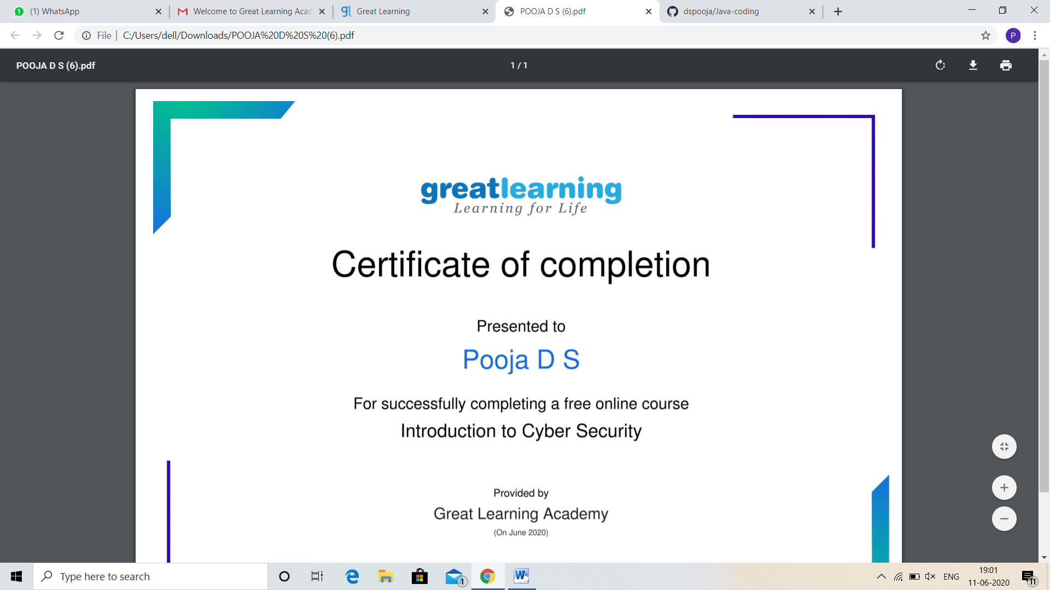

And I Participated in “Technical Quiz by CSE Department”. This is my certificate.

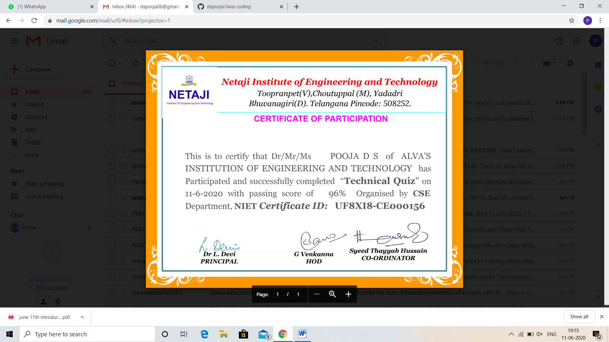

And I participated in Webinar on Skill Development its 1:30 min.

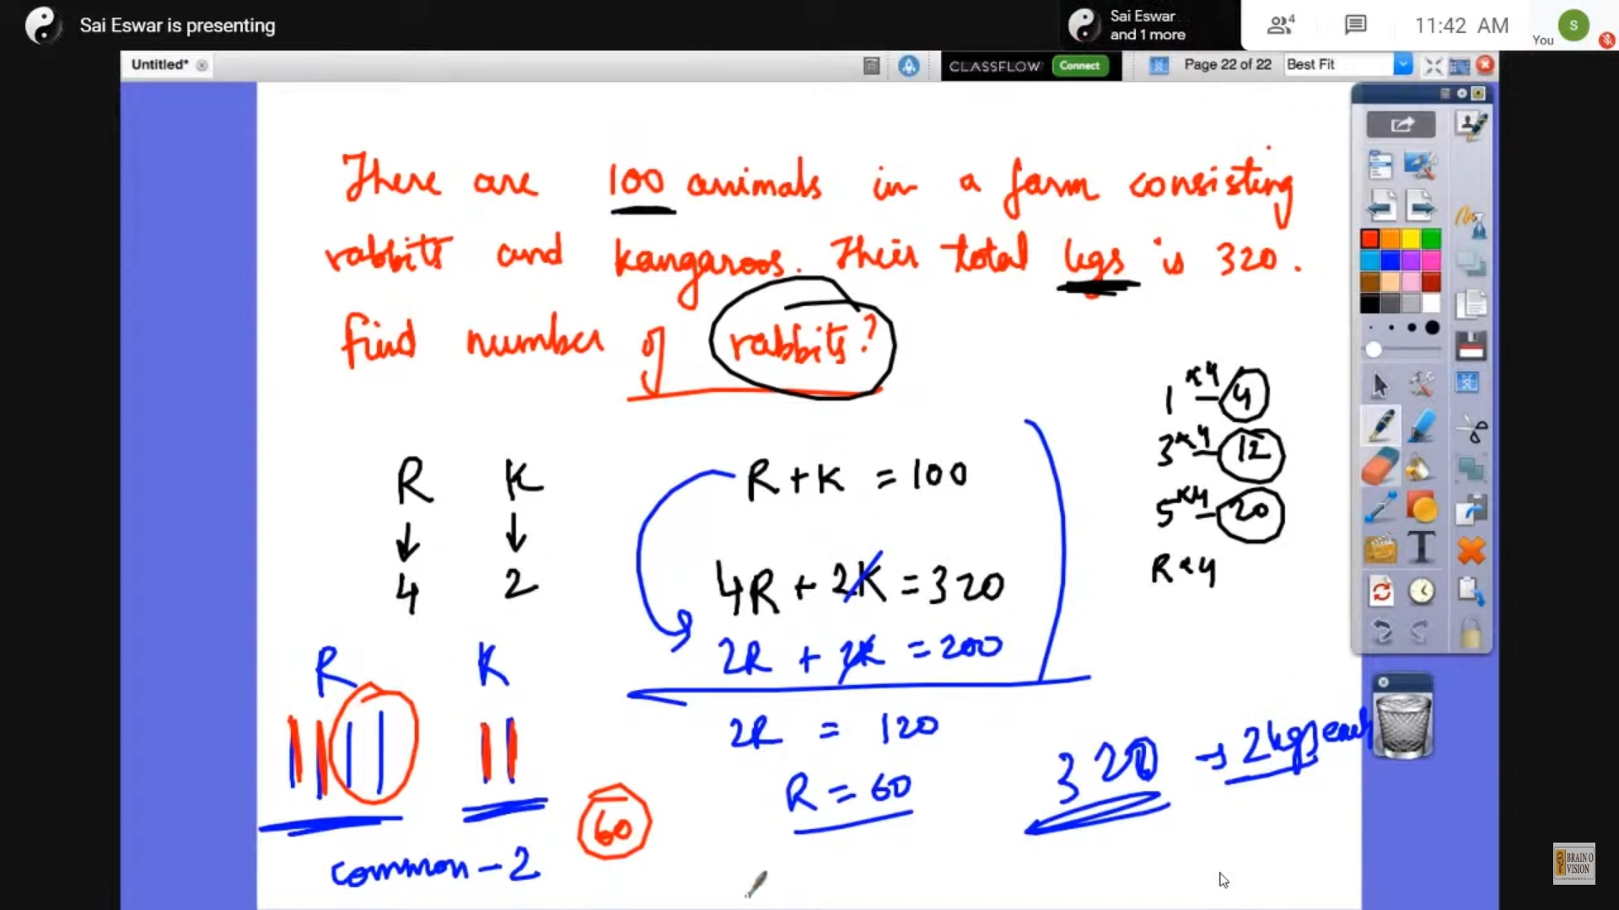

CODING CHALLENGES DETAILS:

Problem statement 1:

Write a Java Program to Segregate Even and Odd numbers.

Given an array A[], write a function that segregates even and odd numbers. The functions should put all even numbers first, and then odd numbers.  
Example:

Input = {12, 34, 45, 9, 8, 90, 3}  
Output = {12, 34, 8, 90, 45, 9, 3}

Solution: Uploaded it in github.

